**HBS Open Buybacks:** HBS Open Buybacks allows users to view and manage their open CNH buybacks from the NetView Desktop ordering programs, as well as verify and ultimately submit them to CNH for processing.

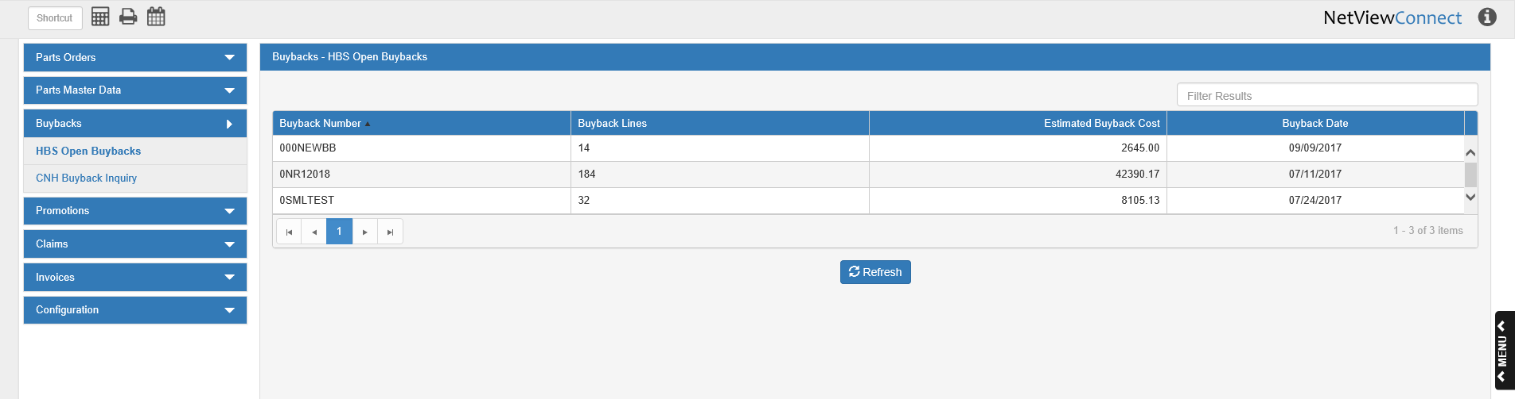

You can sort the list of open buybacks using the column headers, or filter the list by entering specific information in the **Filter Results** field.

**Column Headers:**

Buyback Number: This column shows the dealer-assigned buyback number.

Buyback Lines: This column shows how many lines are on the buyback.

Estimated Buyback Cost: This column shows the estimated cost of the buyback.

Buyback Date: This column shows the buyback’s creation date.

**Refresh:** Click this button to update the open buyback list. The list will change to reflect any new orders as well as any alterations to existing orders.

**Verifying Buybacks:** To view and verify a buyback, click on the buyback’s entry in the grid. The following window will appear:

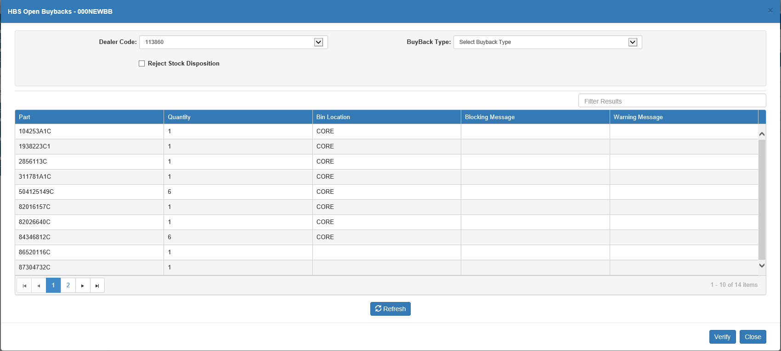

You can sort the buyback lines using the column headers, or filter them by entering specific information in the **Filter Results** field.

Dealer Code: Set the dealer code for the buyback. This applies mainly to dealers that have more than one CNH code.

Buyback Type: Set the buyback type. This will generally be “3-Surplus Buyback,” though some dealers may have other options. Note that this is a **required** field—you cannot verify the buyback without a type.

Reject Stock Disposition:

* Check this box to reject the stock disposition for the buyback.
* Leave it blank to accept the disposition.

Grid Columns:

**Part:** This column shows the part number for the buyback line.

**Quantity:** This column shows the part quantity for the buyback line.

**Bin Location:** This column shows the bin location for the part on the buyback line.

**Blocking Message:** This column will typically be **blank** in this screen. It is reserved for use after the line is verified.

**Warning Message:** This column will typically be **blank** in this screen. It is reserved for use after the line is verified.

Refresh: Click this button to update the buyback details. Any changes made to the buyback since it was opened in this screen will appear.

Close: Click this button to close the screen.

Verify: Click this button to send the buyback to CNH for verification. If the verification is successful, this screen will close and be replaced with the CNH Buyback Details screen (see below).

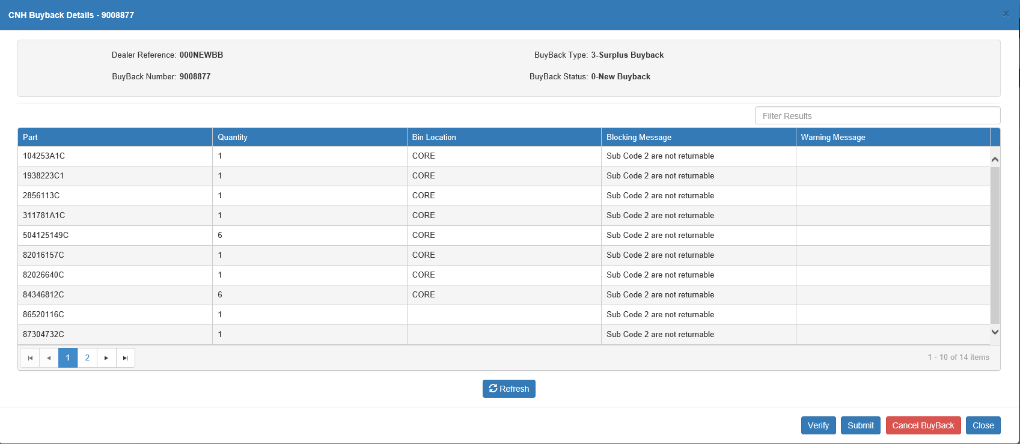

**CNH Buyback Details**: This window appears after you send the buyback for verification successfully. You can sort the buyback lines using the column headers, or filter them by entering specific information in the **Filter Results** field.

Dealer Reference: This field shows the dealer-assigned buyback number.

Buyback Number: This field shows the CNH-assigned buyback number.

Buyback Type: This field shows the buyback type.

Buyback Status: This field shows the buyback’s current status.

Grid Columns:

**Part:** This column shows the part number for the buyback line.

**Quantity:** This column shows the part quantity for the buyback line.

**Bin Location:** This column shows the bin location for the part on the buyback line.

**Blocking Message:** If there is an error blocking a buyback line from being submitted, a blocking message will appear here.

**Warning Message:** If there is a warning on a buyback line, a warning message will appear here.

Refresh: Click this button to update the buyback details. Any changes made to the buyback since it was opened in this screen will appear.

Verify: Click this button to re-send the buyback for verification. We recommend this particularly after you have corrected any blockers on the buyback to make sure that the blocking messages have been removed.

Submit: Click this button to submit the buyback to CNH for processing.

Cancel Buyback: Click this button to cancel the buyback's simulated status, which will cause the system to treat the buyback as though you never simulated it in the first place.

Close: Click this button to close the screen.